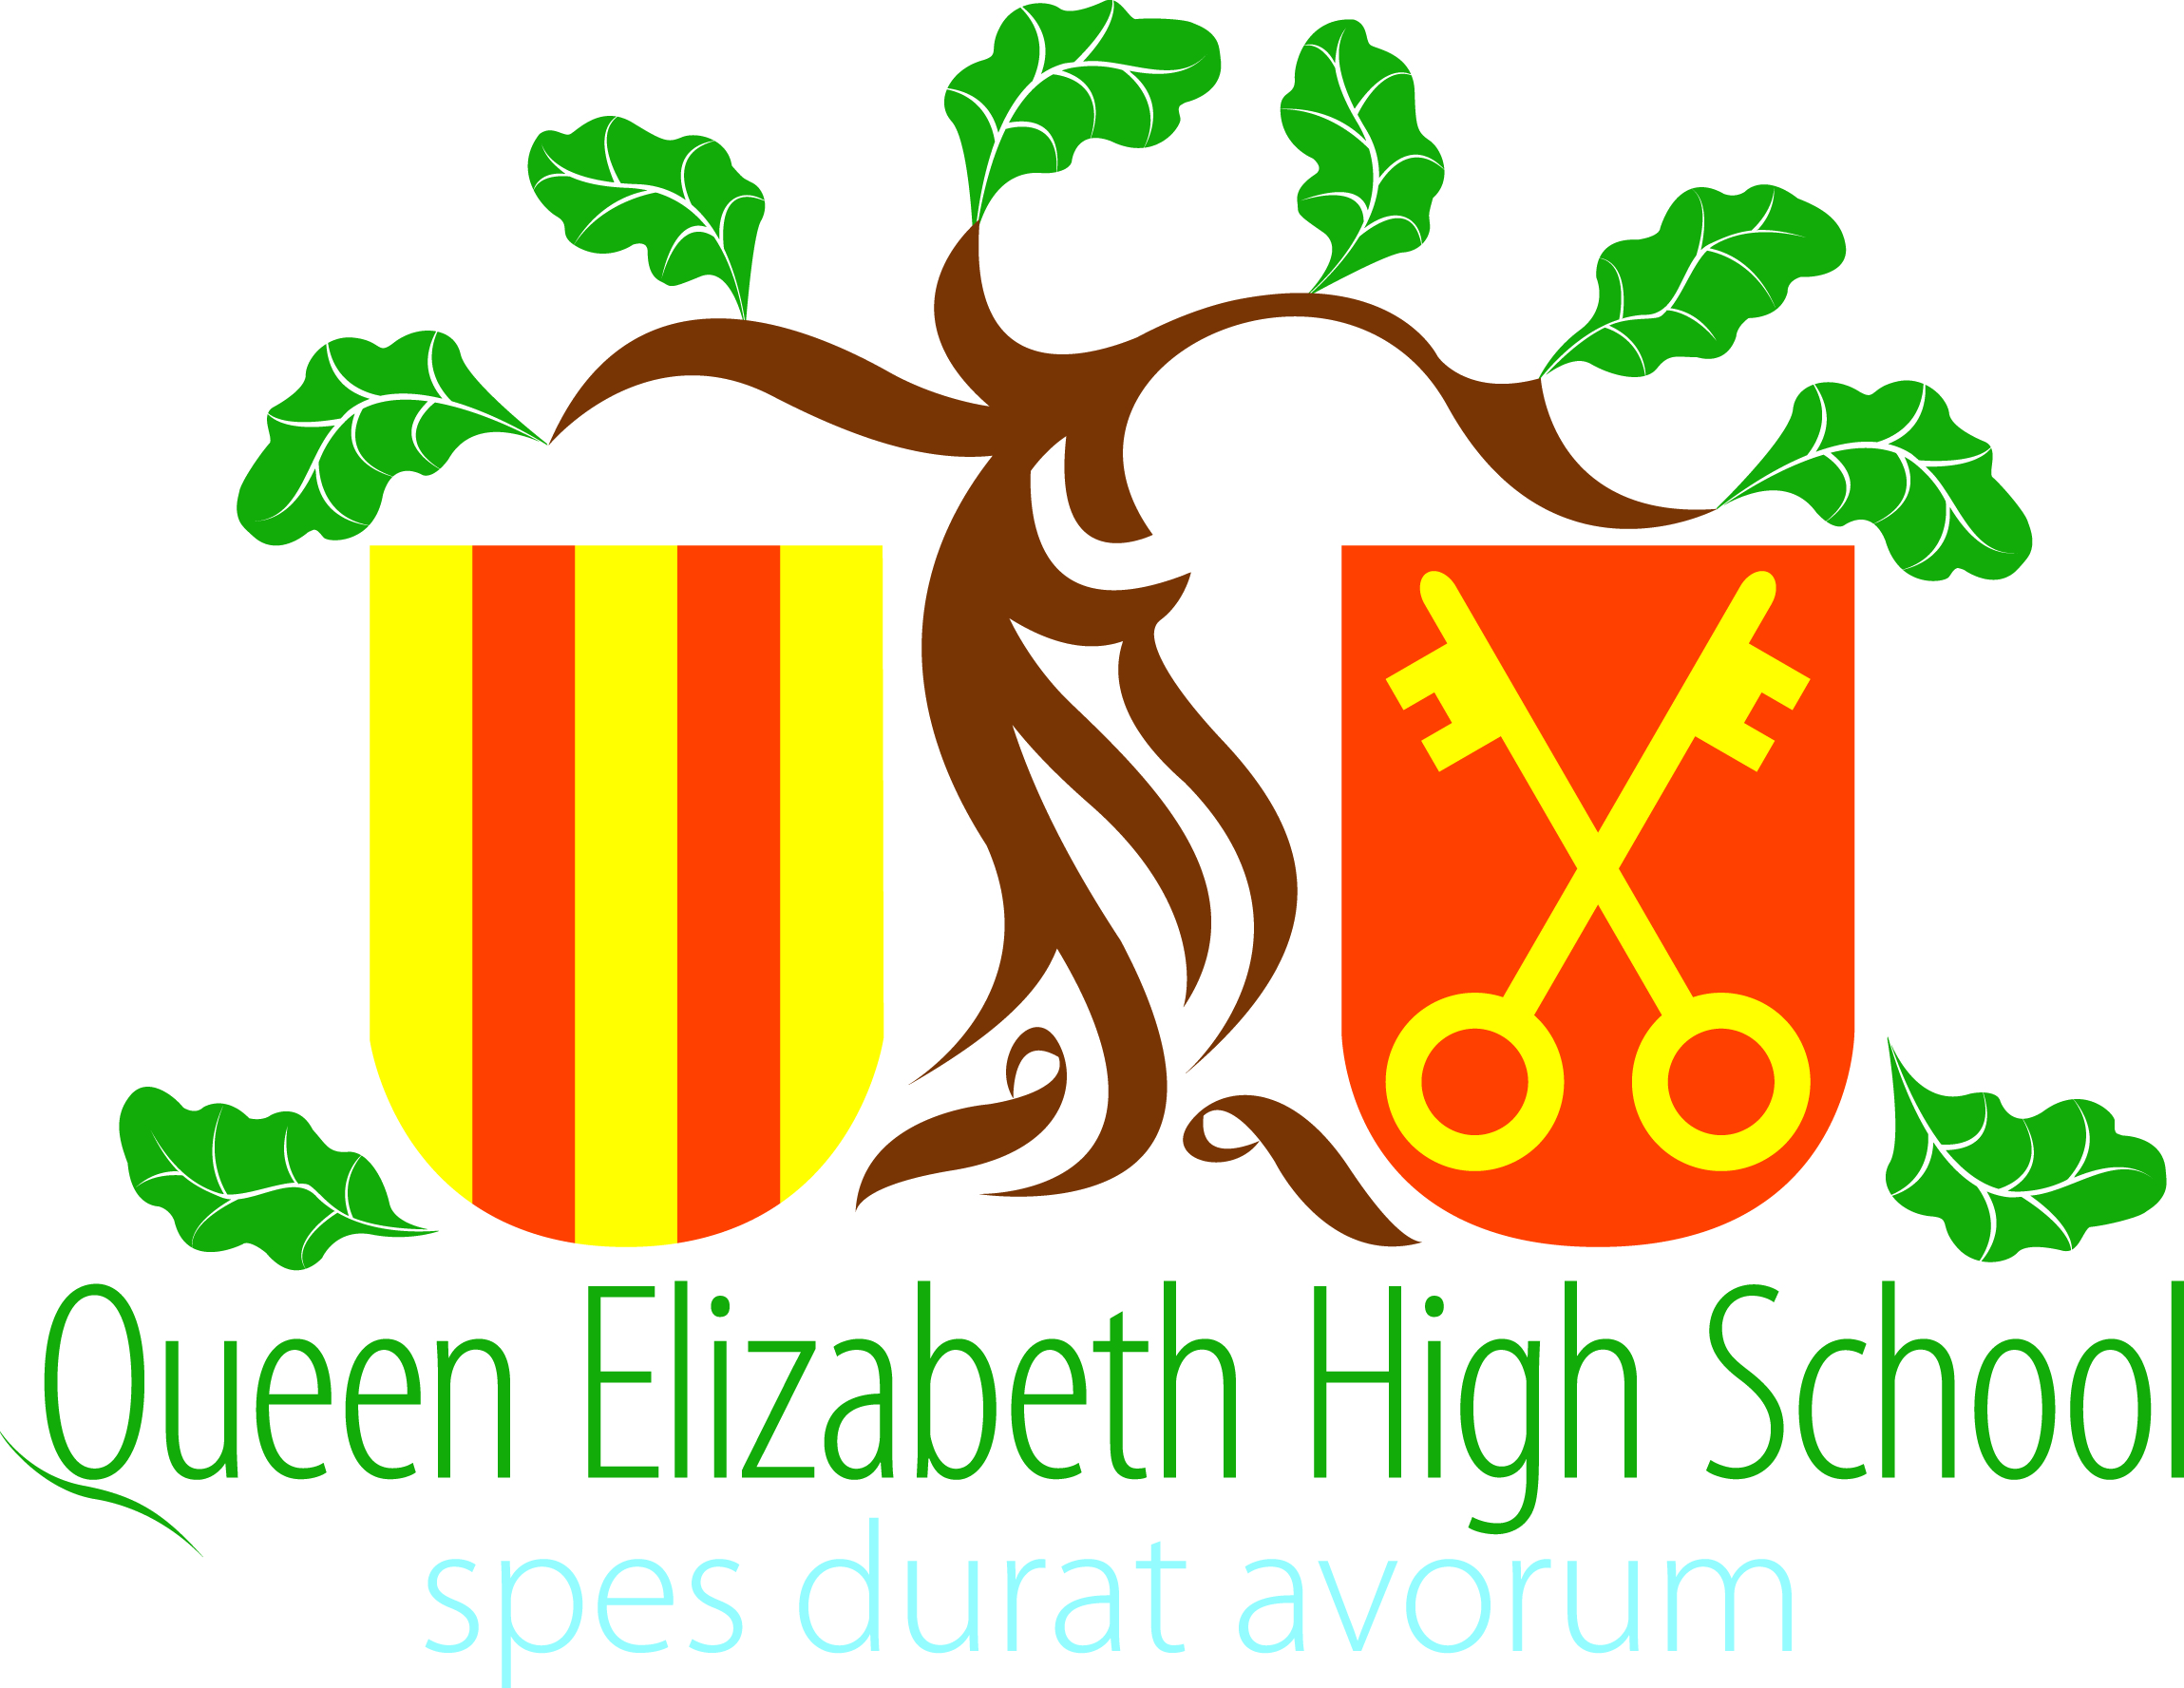
QEHS Alumni: Careers Questionnaire

At QEHS, we are committed to careers education to ensure that our students are successful, prosperous and happy in their future lives. The aim of this questionnaire is to show our students just how many employment opportunities are out there, how everyone's career journey is different and the many routes they can take using the subjects that they're currently studying. They might discover a career that they'd never considered before, or reinforce their decision to take a certain path, or even perhaps learn not to make the same mistakes that others did when they were here! Your answers, experience and knowledge will be greatly appreciated and will be invaluable to the students who are now in the same position that you were back when you were at QEHS.

Your answers to this questionnaire, your name and any photos submitted will be used:
1) to make careers-related displays around school
2) in lessons/careers guidance sessions with students
3) in the careers and/or alumni sections of our website

We may edit your submissions for length and clarity.

All data will be used in accordance with our Data Protection Policy, which is available by clicking here or through the QEHS website. You can request a copy of your data or ask for it to be deleted at any time by contacting the school office or emailing admin@qehs.net

If you agree to the above terms and consent to your personal data being processed as described above, please complete the form below and return it via email to lcampbell@qehs.net

Name

What was your favourite subject at QEHS?

Out of all the subjects you studied during your time at QEHS, which ones do you use in your current job?

With hindsight, is there anything you would have done differently while you were at QEHS?

What did you learn about yourself while you were at QEHS?

What were your next steps after leaving QEHS? (e.g. college, university, employment, gap year)

What is your current job?

Describe a typical day in your job.

Describe your career journey: how did you get to where you are today?

What advice would you give to current QEHS students thinking about their future careers?

Please delete as appropriate:
Would QEHS be able to contact you with regard to future careers guidance for our students?
Yes / No
Did you also attend Hexham Middle School?
Yes / No
If you did attend HMS, would HMS be able to contact you with regard to careers guidance?
Yes / No

Thank you so much for completing our questionnaire! As we’d like to turn the responses into displays for our students, if you have a photo of you when you were at QEHS or a photo of you now in your workplace that you could email to us along with your form that would be greatly appreciated.

Please send your completed form to lcampbell@qehs.net

