Year 12 Geography Preparation Tectonic Processes and Hazards
If you are interested in undertaking some wider geographical reading, you can find some recommended reads for A level geographers here https://www.internetgeography.net/wider-reading-in-geography/ Each has a link to show you where you can get them from. Books like Prisoners of Geography and the Almighty Dollar are particularly recommended and will provide valuable background knowledge, which you can draw on throughout the course.
The following tasks will build on the knowledge you have gained in the GCSE tectonics unit and lay the foundations for the topic you will begin at the start of September. In addition to these tasks, you could review your GCSE tectonics work, some of which I overlapped here. The YouTube video is taken from an A level revision channel created by a teacher from another school. That teacher refers to a task sheet that is different to the tasks you are doing and you should ignore his instructions
Part 1: https://www.youtube.com/watch?v=znSj6ElG81c Watch the video and answer the questions as you watch
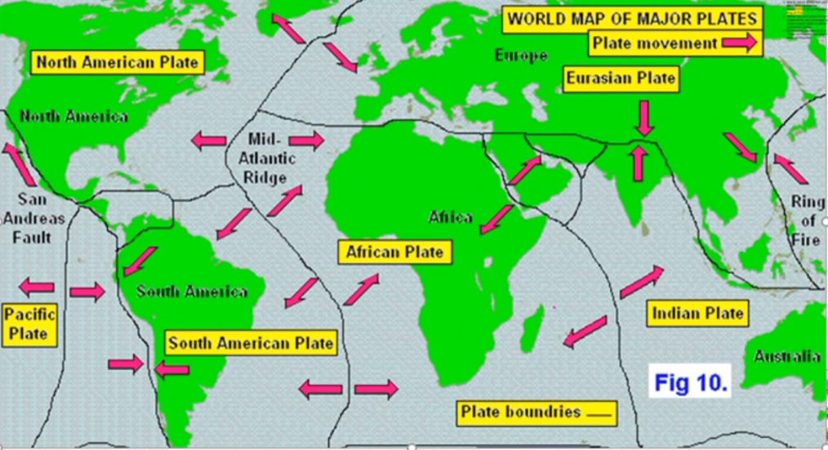
- What are the 3 types of plate boundaries?
- From the map of the distribution of plate boundaries, for each type of plate boundary, name an example of two plates which share that type.
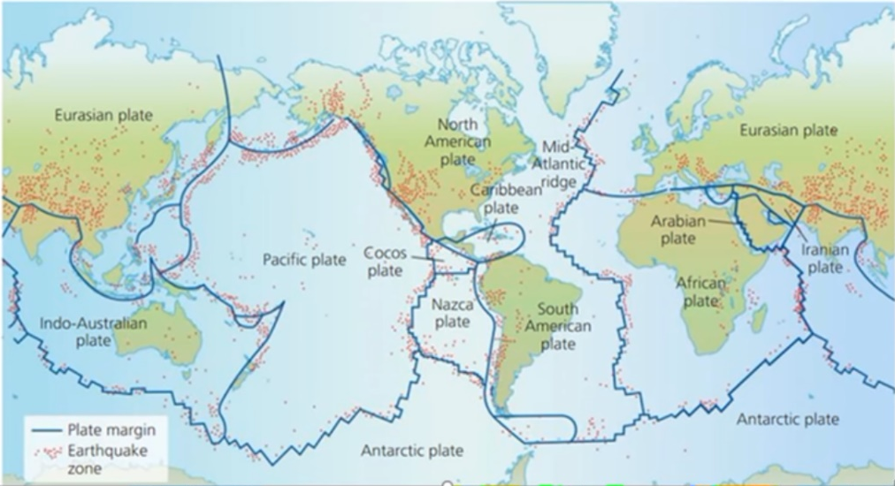
- Describe the global distribution earthquakes.

- 70% of earthquakes occur where?
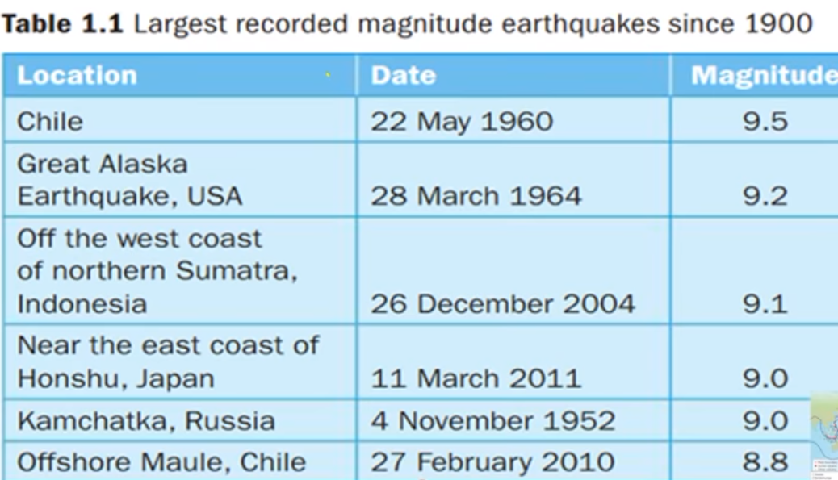
- The highest magnitude/megathrust earthquakes are found at which plate boundaries?
- Which plate boundaries have shallow-focus medium-high earthquakes?
- At which plate boundaries do you find the lowest magnitude earthquakes?
- Use the table of the largest magnitude recorded earthquakes as a key and plot their location on the map by drawing a symbol/arrow.
- Describe how earthquake risk varies depending on location.
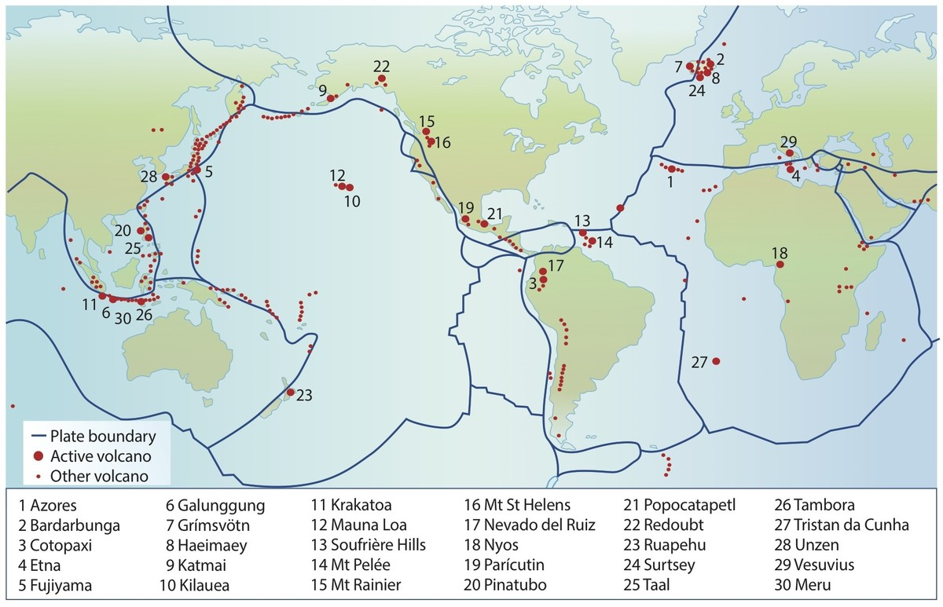
- Describe, using examples, the global distribution of volcanoes.

- Define tsunami.
- Describe the distribution of tsunami risk.
- Define tectonics plates.
- How and where are convection currents (cells) produced?
- What is the cause of subduction zones?
- What is ridge push?
- What is slab pull?
- Draw a diagram with annotations which explains the theories of ridge push and slab pull
- How do mantle plumes create hot spots? Include an annotated diagram.
Part 2 Case studies research task: Watch the documentaries below and answer the questions while you watch.
Volcanoes in Italy https://timeforgeography.co.uk/videos_list/plate-tectonics/living-shadow-italys-volcanoes/
Mt Vesuvius
- What is the tectonic setting of the volcano? (plates/boundary type/activity)

- How many people live in the wider area of Naples below Mt Vesuvius?
- How many people would need to evacuate in the event of an eruption?
- What changes are being monitored by the volcanologists?
- In the town of Pozzuoli, what has happened to the ground level and why?
Mt Etna
- What hazards are present from Mt Etna and what is the level of danger?
- What hazard management strategy has been put in place after the 2002 lava flows to protect the gift shops?
- In 1993, what happened when the authorities on Sicily tried to divert the lava flows?
Eyjafjallajokull 2010 eruption https://timeforgeography.co.uk/videos_list/plate-tectonics/eyjafjallajokull-case-study/
- What were the various hazards of the eruption and what was their significance?
- How are volcanoes monitored in Iceland?

