A-level Biology @ QEHS – Yr 11 Transition work 3

Complete the tasks in as much detail as you can. Use any available resources you have including textbooks (Kerboodle has the A-level biology text books), revision guides (you can access some on Kindle for free) and online resources to complete the tasks. Several topics are covered in the first 2 transition booklets, so this booklet will cover elements of topics 1 & 2 not previously covered.

Topic 1: Biological molecules

This is the first topic in A-level Biology and will be taught by one of your teachers. There is an activity in the Oxford transition work (page 11) to help with some of the key principles.
There is a high chemistry demand linked to Unit 7 (carbon chemistry) from GCSE. For triple students, it would be worthwhile going back over this using revision guides and Seneca. For combined students, it would be a good idea to access the GCSE chemistry text book and look over this section and use Seneca to learn and review this area of GCSE chemistry.

Task 1
At A level we look at the structure of DNA in detail. This was covered only in GCSE biology, for those of you who followed combined science you can use the GCSE text book (pages 202-4) to help. In the space below draw and label what you can remember about DNA. Fill in the missing words where appropriate.

DNA stands for ____________________

A monomer of DNA is called a ____________

The monomer of DNA is made up of 3 components s______, p________ and a nitrogen b______

A polymer of DNA is called a ___________

There are 4 different types of base present in DNA. They are called __________, __________, _____________ and __________

A nucleotide looks like this:

Task 2

You will also be studying digestive enzymes in topic 1. Complete the table below to review some of the enzymes, substrates and products that you came across in topic 2 GCSE (Organisation).

Name of Enzyme | Substrate | Products
Lipase
 | Fats (lipids)
 |  | Amino acids

Topic 2: Cells

The second topic in A-level Biology is taught at the same time as topic 1 by your other teacher. It covers the structure of eukaryotic and prokaryotic cells; cell transport and the cells associated with the immune system. There are several tasks in the other 2 transition booklets to help you with this.

Task 3
As well as prokaryotic and eukaryotic cells (covered in the AQA transition guide), you also need to recap the structure of bacterial cells. Draw and label a bacterial cell in the box below and annotate each label with the function of the part.

Task 4
You looked at the cell cycle and mitosis in Yr 10 as part of the cells topic. You will look at this in more detail at A-level.
The cell cycle is made up of the 3 stages, I____________, Mitosis & C_____________. Below is a simple diagram of mitosis. Add some descriptions to the side and then finish the sentences below.

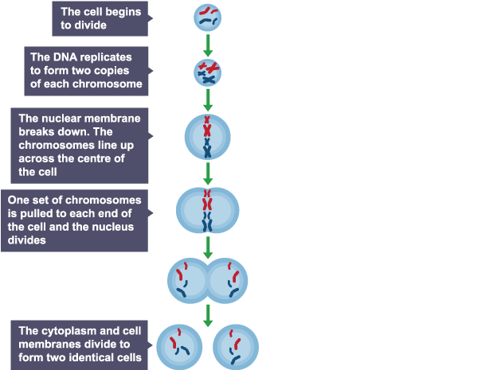

Interphase is the first stage of the cell cycle. During this stage….

The process of mitosis produces….

Cytokinesis is….

In mitosis, the chromosome number….

Task 4

Topic 3: Exchange

Task 5
The immune system is a complex area of biology. You covered this in topic 3 ‘communicable disease’ at GCSE, and you will look at this in quite a bit more detail in Yr 12. For this task we would like you to produce either a diagram or a written description of how the body destroys pathogens when they enter the body. Your diagram/explanation should include the following: phagocytosis, antibodies, antitoxins.

Please e-mail this completed booklet to Mrs Fletcher-Woods (afletcherwoods@qehs.net)
If you print it out to complete, please use camscanner or microsoft lens and send it back to us as a pdf.
One of the biology teachers will review it and send you any appropriate feedback.

