A-level Biology – Yr 11 Transition work 4

Complete the tasks in as much detail as you can. Use any available resources you have including textbooks (Kerboodle has the A-level biology text books), revision guides (you can access some on Kindle for free) and online resources to complete the tasks. Several topics are covered in the first 3 transition booklets, so this booklet will cover elements of topics 3 not previously covered.

Topic 3: Exchange
This is the third topic in A-level Biology and will be taught by one of your teachers. There is a strong link to GCSE topic 2 (Organisation).

Task 1
The structure and function of the circulatory system features in this topic.
Complete the following tasks:

- Describe the function of the heart.

- Describe the function of the blood.

The diagram below shows the structure of the mammalian heart.

- Label the diagram in as much detail as you can.

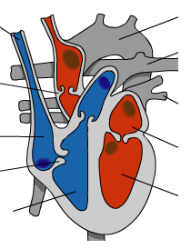

- Write a brief description for each part you have labelled.

……………………………………………………………………………………………………………………………………………………………………………………………………………………………………………………………………………………………………………………………………………………………………………………………………………………………………………………………………………………………………………………………………………………………………………………………………………………………………………………………………………………………………………………………………………………………………………………………………………………………………………………………………………………………………………………………………………………………………………………………………………………………………………………………………………………………………………………………………………………………………………………………………………………………………………………………………………………………………………………………………………………………………………………………………………………………………………………………………………………………………………………………………………………………………………………………………………………………………………………………………………………………………………………………………………………………………

Task 2

There are three major types of blood vessels in the human circulatory system: veins, arteries and capillaries.

Complete the table below to summarise the difference in structure and function between these blood vessels.

 | Function | Structure
Arteries | Carry oxygenated blood (blood containing oxygen) away from the heart at high pressure
Veins
Capillaries
Extension – research task (for an extra challenge – not compulsory, just for fun)
Find out what tissue fluid is and what its role is.

Task 2
Many processes in this topic rely on cell transport (covered in A-level topic 2). Let’s review 2 of the key processes that you will need to have a really good grasp of.
Write a brief summary describing each of these methods of transport in a cell (include diagrams if it helps).

Diffusion

…………………………………………………………………………………………………………………………………………………………………………………………………………………………………………………………………………………………………………………………………………………………………………………………………………………………………………………………………………………………………………………………………………………………………………………………………………………………………………………………………………………………………………………………………………………………………………………………………………………………………………………………………………………………………………………………………………………….………………………………………………………………………………………..…………………………………………………………………………………………………………………………………………….………………………..

Active Transport

………………………………………………………………………………………………………………………………………………………………………………………………………………………………………………………………………………………………………………………………………………………………………………………………………………………………………………………………………………………………………………………………………………………………………………………………………………………………………………………………………………………………………………………………………………………………………………………………………………………………………………………………………

Task 3
- Label the diagram below to show the key structures found in the lungs.
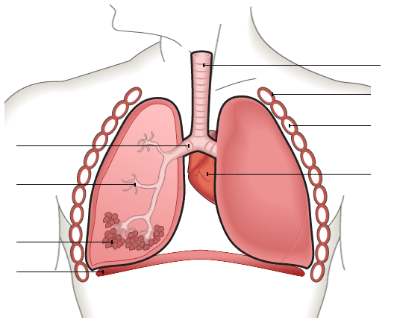

- Explain the adaptations of the alveoli and how gas exchange occurs using the terms diffusion and concentration gradient:

………………………………………………………………………………………………………………………………………………………………

………………………………………………………………………………………………………………………………………………………………

………………………………………………………………………………………………………………………………………………………………

………………………………………………………………………………………………………………………………………………………………

………………………………………………………………………………………………………………………………………………………………

………………………………………………………………………………………………………………………………………………………………

………………………………………………………………………………………………………………………………………………………………

………………………………………………………………………………………………………………………………………………………………

……………………………………………………………………………………………………………………………………………………………….

Task 4
You will look closely at the role of the digestive system and how absorption takes place efficiently. Label the diagram below and annotate the diagram of the small intestine with as many adaptations and explanations as to how they help to speed up absorption.

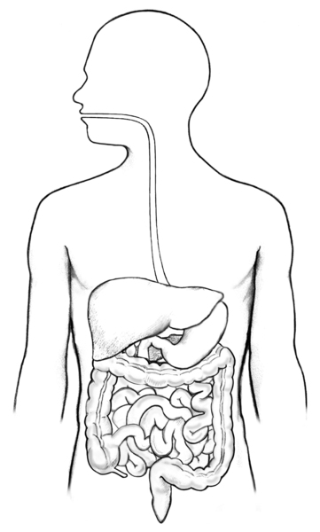

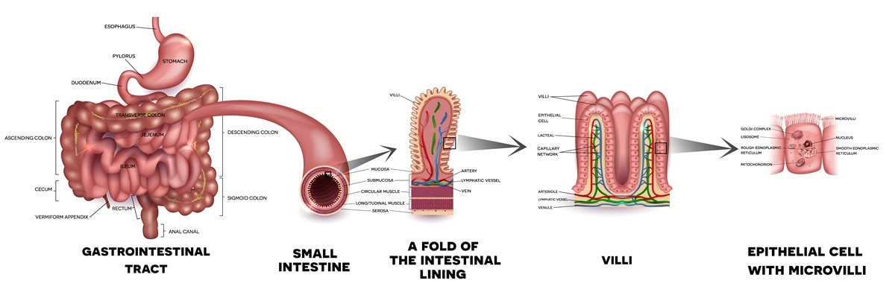

Task 5
Exchange also occurs in plants. One of the key exchange organs is the leaf. Can you remember the different cell and tissues of the leaf?
- Label the leaf below and include any annotations for the role of that particular cell or tissue.
- Mark an x on the leaf where gas exchange takes place
- Mark a y on the leaf for anywhere that evaporation takes place

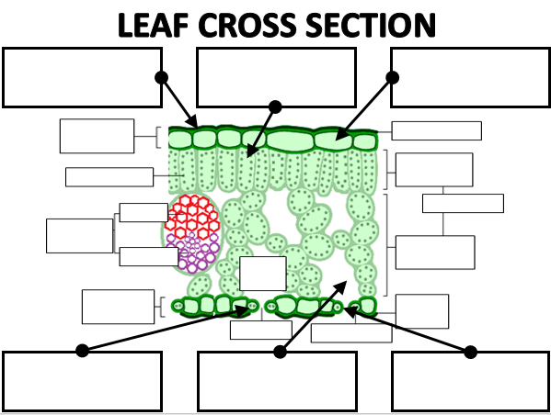

Task 6
All of the body systems and processes that you have reviewed in this booklet rely on surface area for efficient exchange. We need to understand why. Watch the following video and explain the importance of surface area for each of the organs/organ systems covered in this booklet.
https://www.youtube.com/watch?v=huKUJsqik2I

Circulatory system…………………………..

Respiratory system…………………………….

Digestive system………………………………

Leaves……………………………

Please bring this completed booklet along with your two research tasks to your first Biology lesson. We will mark your work in class and go through any problems you had. Your teacher will mark your research tasks and give you feedback.

