A-level Biology – Yr 11 Transition work 5

Complete the tasks in as much detail as you can. Use any available resources you have including textbooks (Kerboodle has the A-level biology text books), revision guides (you can access some on Kindle for free) and online resources to complete the tasks. Several topics are covered in the first 4 transition booklets, so this booklet will cover elements of topics 4 not previously covered.

Topic 4: Genetic Information & Variation
This is the forth topic in A-level Biology and will be taught by one of your teachers, usually alongside topic 3. There is a strong link to GCSE topic 6 (Inheritance, Variation & Evolution).

Task 1
The first topic that you will cover is protein synthesis, this is a very tricky topic. This is only covered on the GCSE biology course. Those of you who followed combined science, it would be a good idea to read up on this in the GCSE biology text book (pages 204/5) which you can find on Kerboodle. The following video may also help
https://www.youtube.com/watch?v=1GgNNYZ47rk

Answer the following questions:
- What are proteins made up of?..............................................................................................................
- What determines the shape and function of the protein?

................................................................................................................................................................
- What is the link between the sequence of DNA bases, amino acids & proteins?

…………………………………………………………………………………………………………………………………………………………..
- What is mRNA?

…………………………………………………………………………………………………………………………………………………………..

- Where are proteins made?

…………………………………………………………………………………………………………………………………………………………..
- Draw a diagram to outline the process of protein synthesis:

Task 2
You briefly looked at mutations at GCSE. Again, this was on the GCSE biology course only.
- Research task – look for a definition of mutation and find some examples that affect humans, other animals and plants.

- What effect does a mutation in the DNA have on the protein it codes for (for bonus points, can you explain why)?

…………………………………………………………………………………………………………………………………………………………………………………………………………………………………………………………………………………………………………………………………………………………………………………………………………………………………………………………………………………………………………………………………………………………………………………………………………………………………………………………………………………………………………………………………………………………………………

Task 3
You will need to study the other type of cell division in this topic. You have already looked at the cell cycle and mitosis. We now need to remind ourselves about meiosis. This is easily confused with mitosis so we need to be careful and understand when and where meiosis is used in living things.
Annotate the diagram below and then complete the sentences:
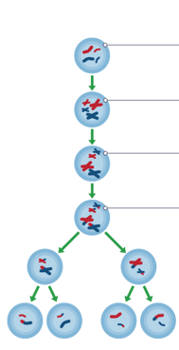
Meiosis happens in…

It produces g…………

The chromosome number in the daughter cells.....

It is different to meiosis because…..

It is important to life on earth because……

Task 4
Natural selection and genetic diversity are a big part of this topic. Let recap natural selection by explaining what is happening in the diagram below. Let us assume that these snails live in an environment that is muddy and has lots of dark coloured stones. There are also birds present who predate the snails.
Use the following words in your explanation: population, variation or mutation, alleles, favourable, advantage, survival of the fittest, over time, survive and reproduce

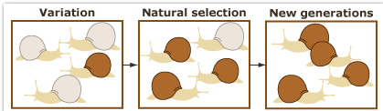

Task 5
All living things are classified using a particular system of taxonomy. You looked at 2 different methods of classification at GCSE but at A-level we only really focus on one.
- Write a definition of a species ……………………………………………………………………………………………………………………………………………………………………………………………………………………………………………………………………………………………………………………
- Complete the hierarchy of classification for living things:

Kingdom

P

C

Order

F

G

Species
- Choose 2/3 living things and find their classification hierarchy.

