GCSE to A level
transition booklet

PHYSICS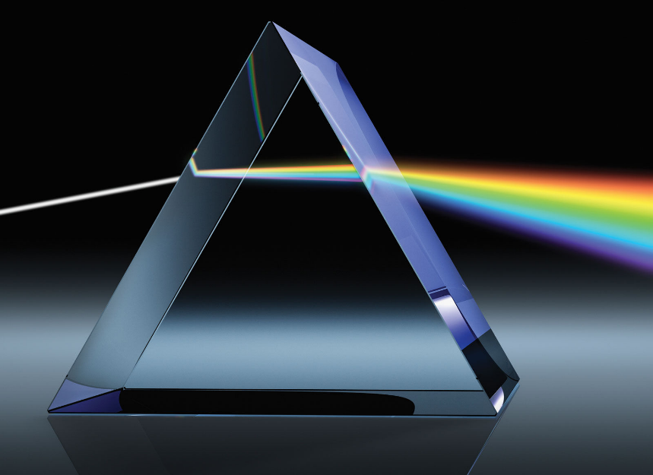

Name: _________________________

Welcome to A-level Physics.

You have made an excellent choice and are about to embark upon a truly fascinating journey. You may be feeling anxious that, having not sat your GCSE exam, you are not going to be as well prepared for your A levels as previous students. We have prepared this booklet so that you and your teachers can start the course with confidence.

This booklet contains:
- Tasks linked to the topics you will cover in Year 12 to help you recap your GCSE knowledge.
- Tasks to help you develop some of the skills you will need to succeed in A level Physics.
- Tasks to inspire your passion for physics!

The transition from GCSEs to A-levels is challenging, and we as teachers expect mature and organised students, but most of all we want you to be passionate about our subject. Physics is about understanding the Universe around us, so have a go, and remember even some of the greatest Physicists got it wrong!

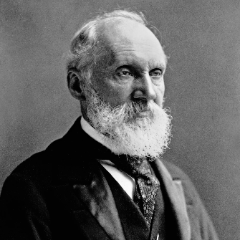 Lord Kelvin: ”X-rays will prove to be a hoax.”!

Course information:

- We will be following the AQA A-level Physics specification:
https://filestore.aqa.org.uk/resources/physics/specifications/AQA-7407-7408-SP-2015.PDF
- You will sit three exams at the end of Year 13, each contributing ≈33% towards your
A-level qualification

Physics lesson information and expectations:

- You will attend 10 x 60 minute lessons each fortnight
- Lessons and assessments will consist of both practical skill and theory content
- You must complete at least 12 assessed practical investigations during the A-level course
- Tests will take place at the end of each topic and each unit.

If you have any questions regarding the course or require any help, please email: cwright@qehs.net

Atomic Structure (Particles and Quantum Phenomena at A level)
You will study nuclear decay in more detail at A level covering the topics of radioactivity and particle physics. In order to explain what happens you need to have a good understanding of the model of the atom. You need to know what the atom is made up of, relative charges and masses and how sub atomic particles are arranged.

The following video explains how the current model was discovered www.youtube.com/watch?v=wzALbzTdnc8

- Describe the model used for the structure of an atom including details of the individual particles that make up an atom and the relative charges and masses of these particles. You may wish to include a diagram and explain how this model was discovered by Rutherford.

This animation shows radioactive decay, nuclear radiation and half life:
https://phet.colorado.edu/sims/cheerpj/nuclear-physics/latest/nuclear-physics.html?simulation=radioactive-dating-game.
- Use it to make simple notes/diagrams about these concepts.

To get a head start on A level particle physics, watch this FERMILAB video about the Standard Model of Physics: https://www.youtube.com/watch?v=XYcw8nV_GTs

Electricity
You will delve deeper into electricity so you need to have a really solid understanding of the basics from GCSE.
- Define:
Current -
Voltage -
Resistance -

Watch this video https://www.youtube.com/watch?v=x2EuYqj_0Uk and then have a go at using the simulation yourself using this link: https://phet.colorado.edu/sims/html/circuit-construction-kit-dc-virtual-lab/latest/circuit-construction-kit-dc-virtual-lab_en.html
Try:
- Building a simple series circuit with a bulb and cell and measuring current and voltage.
- Changing the number of cells/bulbs and observing the effect on the meter readings
- Investigating current and voltage in a parallel circuit.
- Explaining your observations.

- Add the missing currents to these diagrams:
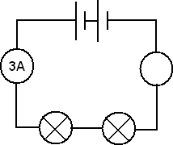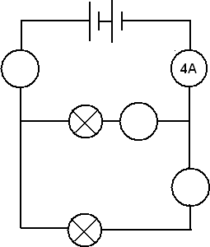
- Add the missing potential differences to these diagrams:
- Complete this simple table showing circuit rules:
 | CURRENT | POTENTIAL DIFFERENCE
SERIES
PARALLEL

- Watch this: Shock and Awe – the story of electricity with Jim Al-Khalili: https://youtu.be/Gtp51eZkwoI
Forces and Motion (Mechanics at A level)
Have a play with these animations: https://www.physicsclassroom.com/Physics-Interactives/Newtons-Laws to help you recap Newton’s Laws of Motion.
- State and draw labelled diagram examples of:
  - Newton’s 1st Law of Motion

  - Newton’s 2nd Law of Motion

  - Newton’s 3rd Law of Motion

- Sketch a graph to show how the velocity of a skydiver changes over time.
- Describe the forces and motion at each stage:

Waves
Waves comes later in the Year 12 course, but important to freshen up your understanding.
- Watch the three lessons that are part of this series:
https://www.khanacademy.org/science/physics/mechanical-waves-and-sound/mechanical-waves/v/introduction-to-waves
- Have a go at the sample questions on these BBC Bitesize pages:
https://www.bbc.co.uk/bitesize/guides/z9khcj6/revision/1 - there are foundation and higher on each page, so you decide if you need to do just higher or recap some basics and do foundation too!
- Complete these tasks:
  - Draw a wave and label the amplitude and wavelength.

  - Draw and label diagrams showing the features of a longitudinal and a transverse wave.

  - Draw a diagram showing refraction as light enters a glass block. Label the normal, angle of incidence and angle of refraction.

Practical skills
Practical skills are a huge part of the A level physics course – there's a whole exam paper dedicated to them, as well as a separate practical endorsement.
Watch this video: https://www.youtube.com/watch?v=uvuqZlcHnvw&t=261s
- Use it to suggest improvements to the results table and graphs below:

- Use this website: https://www.reading.ac.uk/virtualexperiments/ves/preloader-resistivity.html to gather data to investigate the relationship between the length of the wire and its resistance.

- For your report, you need to:
  - Write a method
  - Create a results table
  - Plot a graph
  - Calculate a gradient
  - Draw conclusions
  - Evaluate the method and results

- This video will give you an introduction to uncertainties in experimental data: https://www.youtube.com/watch?v=ul3e-HXAeZA
A graph paper PDF can be found here: http://www.mathsphere.co.uk/downloads/graph-paper/graph-paper-blue.pdf or you can practice using Excel – make sure you still follow the rules for data tables & graphs though - this video should help: https://youtu.be/HyCghkVPgPY!

Research and note-taking
Independent research and note taking is vital for success in Physics. We would like you to prepare 5 brief research papers.
Browse each website and make one page of notes for each, focusing on an area of your choice. Carry out additional research if necessary, quoting sources of information. Include labelled diagrams/graphics if appropriate.
- CERN
https://home.cern/about
- SPACE
https://stellarium-web.org/
- CLIMATE
https://climate.nasa.gov/
- REVOLUTIONS & REVELATIONS IN PHYSICS
https://gizmodo.com/these-17-women-changed-the-face-of-physics-1689043918
https://www.sciencealert.com/20-physicists-who-revolutionised-our-understanding-of-the-world
- FREE CHOICE! Fancy a bit of: black holes…string theory… superconductivity… space travel... be our guest – just remember to reference any sources of information!

Note taking tips:
https://student.unsw.edu.au/notetaking-tips
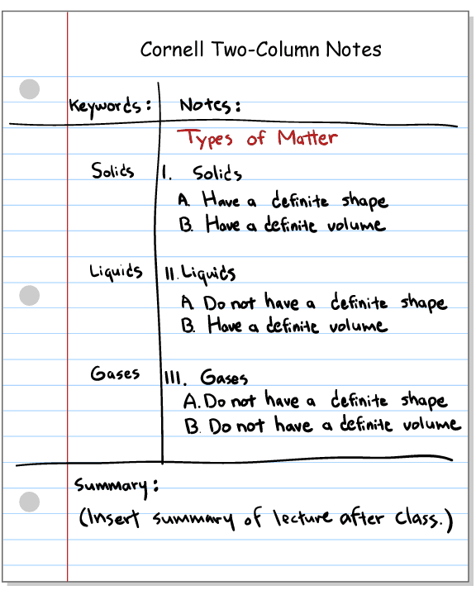
Physics – light entertainment!
Below is a selection of books and films that you may enjoy if you’re stuck indoors...
Books: You may be able to get these free on Audible or through Northumberland libraries online Borrowbox app. Otherwise, all available through most booksellers, reasonably cheaply.
- Particle physics brick-by-brick (by Dr. Ben Still) ISBN: 184403934X Physics and lego – what’s not to love!

- How to (by Randall Monroe) ISBN: 1473680328 Some very imaginative problem solving – what physics is all about really.

- Mr Tompkins in Paperback (by George Gamow) ISBN: 1107604680 A man’s fantastic dreams and adventures inside the atom!

- The infinite lives of Maisie Day (by Christopher Edge) ISBN: 1788000293 Yes, it is a children’s book, but this 10 year old understands relativity. A fascinating story with fascinating physics.

- An astronaut’s guide to life on Earth (by Chris Hadfield) ISBN: 1447259947 Lots of very important lessons for us all about a love of learning, space and the Earth.

- Seven brief lessons on physics (by Carlo Rovelli) ISBN: 9780141981727 They really are brief and very, very beautiful.

- Massive: The Hunt for the God Particle (by Ian Sample) ISBN: 075354153X About the tiny, tiny Higgs and the big, big search for it.

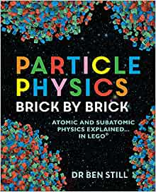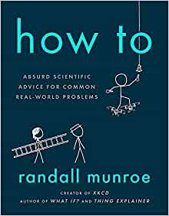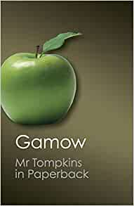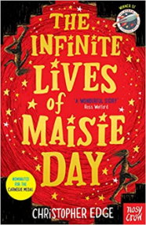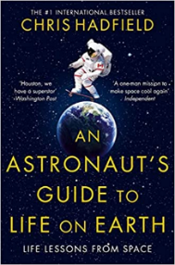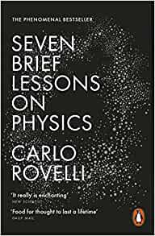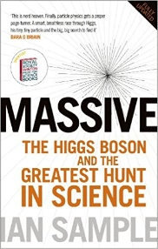
Films: These are just a few of the best physics related films available.
- The Martian (2015) Matt Damon plays a scientist stranded on Mars.
- The Challenger Disaster (2013) Richard Feynman investigates the secrets of the shuttle disaster.
- The Theory of everything (2014) Eddie Redmayne plays physicist Stephen Hawking in the story of his life.
- Einstein and Eddington (2008) David Tennant plays British physicist Arthur Eddington, the first to gather experimental evidence for General Relativity.
- Infinity (1996) The story of the early life of genius, Richard Feynman.
Online video clips/series:
- Minute physics: https://www.youtube.com/user/minutephysics A good start is “Why is it dark at night?”!
- Chernobyl (available through Amazon) A story of conspiracy, heroism and physics.
- Hubble (available on BBC iplayer) A Horizon film, celebrating 30 years since its launch.
- The Planets (available on BBC iplayer) Brian Cox explores our universe.
- All Jim Al-Khalili science documentaries: https://www.youtube.com/watch?v=KFS4oiVDeBI&list=PLBThhL8p7Ifk7ZvlLwiA_4eGDIylVEMac

