Bridging Work - Health and Social Care
Unit 1: Human Lifespan Development – (Task 1)
As part of the health and social care course, we will be starting with an examination unit called Human Lifespan Development. As part of this unit, you will learn about how an individual develops physically, intellectually, socially and emotionally at various ages.
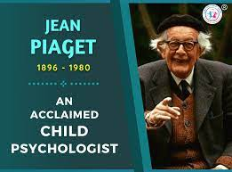
In preparation for starting this course, you are going to a complete an independent research task into various aspects of intellectual development. Individuals during their lifespan develop ways of thinking and learning. Intellectual and cognitive development means the way individuals organise and sort their ideas to make sense of the world.
You will study Piaget’s theory of cognitive development. Jean Piaget was a world-renowned psychologist, who studied the cognitive development of children; babies through to adolescents.
Using the website shown below, read about Piaget’s theory of cognitive development, paying particular attention to the four stages. Use the information you read and research to complete the table below.

Piaget’s Theory of Cognitive Development
Stage | Age | What happens at this stage
Sensorimotor
Pre-operational
Concreate Operational
Formal Operational

https://www.verywellmind.com/piagets-stages-of-cognitive-development-2795457

